# Logistic Regression

**Instructions:**

Please share your answers filled in-line in the word document. Submit code separately wherever applicable.

Please ensure you update all the details:

**Name: Seema Iyengar Batch ID: DataScience_03052023_10AM(20032023)**

**Topic: Logistic Regression**

**Guidelines:**

**1. An assignment submission is considered complete only when the correct and executable code(s) and documentation explaining the method and results are submitted. Failing to submit either of those will be considered an invalid submission and not a correct submission.**

**2. Ensure that you submit your assignments correctly and in full. Resubmission is not allowed.**

**3. Post the submission you can evaluate your work by referring to the keys provided. (will be available only post the submission).**

**Hints:**

1. **Business Problem**
   1. **What is the business objective?**
   2. **Are there any constraints?**
2. **Work on each feature of the dataset to create a data dictionary as displayed in the below image:**

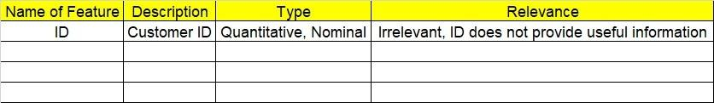**Make a table as shown above and provide information about the features such as its data type and its relevance to the model building. And if not relevant, provide reasons and a description of the feature.**

**Using Python codes perform:**

1. **Data Pre-processing**

**3.1 Data Cleaning, Feature Engineering, etc.**

**3.2 Outlier Treatment.**

1. **Exploratory Data Analysis (EDA):**
   1. **Summary.**
   2. **Univariate analysis.**
   3. **Bivariate analysis.**
2. **Model Building**
   1. **Build the model on the scaled data (try multiple options).**
   2. **Build a Logistic Regression model.**
   3. **Train and test the model and compare accuracies by building a confusion matrix, and plotting ROC and AUC curves.**
   4. **Briefly explain the model output in the documentation.**
3. **Write about the benefits/impact of the solution - in what way does the business (client) benefit from the solution provided?**

Problem Statement: -

1. In this time and age of widespread internet usage, effective and targeted marketing plays a vital role. A marketing company would like to develop a strategy by analyzing its customer data. For this, data like age, location, time of activity, etc. have been collected to determine whether a user will click on an ad or not. Perform Logistic Regression on the given data to predict whether a user will click on an ad or not.

